LAB-1

Assignment-1

Code:

package assignment;

class Student

{

private String studentName;

private String collegeName;

private int studentId;

public static void main(String args[])

{

System.***out***.println("Successful");

}

}

Output:

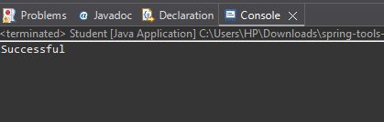

Assignment-2

Code-

class Employee

{

protected int id, age;

protected String name;

protected boolean isPermanent;

public static void main(String args[])

{

Employee emp = new Employee();

//emp.age=35.5;

//As we are assigning a double value to int variable

// error msg - Type mismatch: cannot convert from double to int

// so to correct we need to use type casting

emp.age=(int)35.5;

System.***out***.println("Successfully started");

}

}

Output-

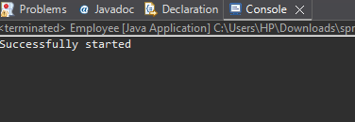

Assignment-3

package assignment.com.anudip.learning;

class Person

{

String name= "Ram";

int age=25;

int salary=60000;

public static void main(String args[])

{

System.***out***.println("Test Successful");

}

}

Output-

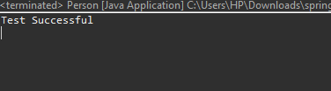

Assignment 4-

package assignment;

class Rectangle

{

double width;

double height;

enum *Color*{

***Red***, ***Green***, ***Blue***;

}

*Color* boxColor;

public static void main(String args[])

{

System.***out***.println(*Color*.***Blue***);

}

}

Output-

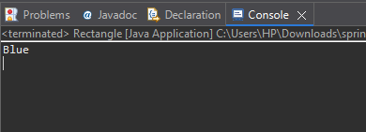

LAB-2

Assignment-1

package assignment;

import java.util.Scanner;

class Car

{

String make;

String model;

short year;

int price;

Car(String make, String model, short year, int price)

{

this.make = make;

this.model= model;

this.year = year;

this.price = price;

}

public void show()

{

System.***out***.println("Car detail");

System.***out***.println("Make :"+ make);

System.***out***.println("Model :"+model);

System.***out***.println("Year :"+year);

System.***out***.println("Price :"+ price);

}

public static void main(String args[])

{

Scanner scanner = new Scanner(System.***in***);

System.***out***.print("Enter Car Make: ");

String make = scanner.nextLine();

System.***out***.print("Enter Car Model: ");

String model = scanner.nextLine();

System.***out***.print("Enter Car Year: ");

short year = scanner.nextShort();

System.***out***.print("Enter Car Price: ");

int price = scanner.nextInt();

Car car1 = new Car(make, model, year, price);

car1.show();

scanner.close();

}

}

Output-

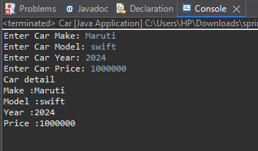

Assignment-2

package assignment;

import java.util.Scanner;

class Calculator

{

int add(int num1, int num2)

{

return num1+num2;

}

int add(int num1, int num2, int num3)

{

return num1+num2+num3;

}

double add(double num1, double num2)

{

return num1+num2;

}

public static void main(String[] args) {

Calculator calc = new Calculator();

Scanner scanner = new Scanner(System.***in***);

System.***out***.println("Enter two integers to add:");

int x = scanner.nextInt();

int y = scanner.nextInt();

System.***out***.println("Sum of two integers: " + calc.add(x, y));

System.***out***.println("Enter three integers to add:");

int a = scanner.nextInt();

int b = scanner.nextInt();

int c = scanner.nextInt();

System.***out***.println("Sum of three integers: " + calc.add(a, b, c));

System.***out***.println("Enter two double numbers to add:");

double d1 = scanner.nextDouble();

double d2 = scanner.nextDouble();

System.***out***.println("Sum of two doubles: " + calc.add(d1, d2));

scanner.close();

}

}

Output:

